Facilitated by:
HUNGER FREE
with

Get up to 1 month of benefits to replace lost food!
You can request replacement CalFresh benefits if your food spoiled due to:
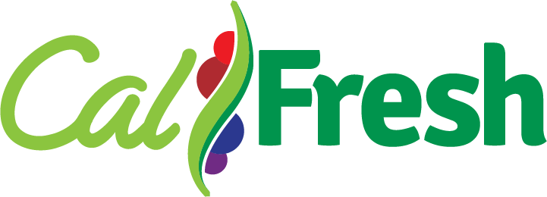
- Power outage lasting longer than 4 hours.
- There was damage from a fire, flood, or storm.
- Utilities were shut off (for any reason).
- Freezer or refrigerator stopped working.
You have up to 10 days after the food was lost to request your replacement benefits.

How do I request replacement CalFresh?
You will need to fill out and submit a Replacement Affidavit/Authorization form (CF-303):

Download the form at sdhunger.org/replacement-calfresh

To submit your form, you may do one of the following:
- Walk it into your local Health and Human Services Office.
- Contact a local CalFresh Application Assistance Provider. Find one at sdhunger.org/calfresh-assistance.
- Submit online at GetCalFresh.org/docs.

Due to COVID-19, you may also call the County of San Diego ACCESS at 1-866-262-9881
to complete the entire request process over the phone.

Questions?
If you need help finding and/or filling out the correct form, submitting your request, or you just have questions, please contact a local CalFresh Application Assistance Provider or do one of the following:

Call County of San Diego Access at 1-866-262-9881
Go online for more resources: sdhunger.org/replacement-calfresh Email the San Diego Hunger Coalition: jaqueline@sdhunger.org
Or contact [insert your organization’s contact info in this text box.]

Last Update 10/30/2020 | Please email jaque@sdhunger.org for more information. | www.sdhunger.org

