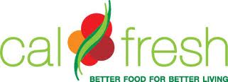

New CalFresh Rules!

Do You Have a Prior Drug Offense?
You may now be eligible for CalFresh!

Starting April 1, 2015, if you have a felony drug conviction, and you are complying with your probation or parole, or have completed probation or parole, you may be eligible for CalFresh!
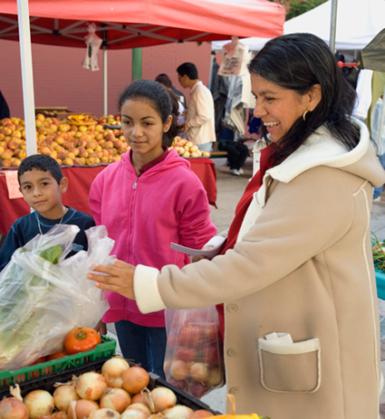
How to Apply
As of March 1st, 2015 you can apply for CalFresh in order to receive benefits in April 2015. Here’s how to apply:

If You Live In a Family with Others Who Receive CalFresh
If you have a drug-related felony conviction and live in a household with other people receiving benefits, your household may be eligible for additional CalFresh food benefits starting April 1, 2015. Contact your county worker to be added to your family’s existing case.

If You Live Alone or No One in Your Family Currently Receives CalFresh
If you are complying with your probation or parole or you are no longer on probation or parole, you may now be eligible for CalFresh and should apply.

  - Go into your County Human Services Agency:
Find a location at http://www.myfoodstamps.org/apply.html
  - Call 2-1-1
  - Apply online at www.mybenefitscalwin.org
  - Apply with the help of a local application assister.

If you’ve never applied for CalFresh or if you have been denied in the past due to your drug-related felony conviction, you should consider applying in March, 2015. If you are in compliance with or have completed probation and meet income requirements, you could benefit from CalFresh!

You may not have to wait until April to receive benefits.
Voters approved Proposition 47 in November, which allows Californians to reclassify certain drug-related felony convictions to a misdemeanor. If your felony conviction(s) is reclassified, you will no longer be banned from CalFresh and can apply immediately. For information about reclassification of a non-violent felony, we recommend: http://www.safeandjust.org/recordchange

For more information about CalFresh rules, go to: www.calfresh.ca.gov.

